**MACHINE LEARNING OPERATIONS PROJECT**

**Deployment of Machine Learning Model on Docker, Kubernetes & Jenkins**

***Group Number: G-2***

***Submitted To: Mr. Chaitainya Soni***

***Submitted By: Rakshit Mohla (2110993825)***

**DOCKER**

1. Docker Installation:

* Visit the Official Docker website
* [www.docker.com/products/docker-desktop](http://www.docker.com/products/docker-desktop)
* Follow installation steps.

1. Make a separate Folder: A .py file containing a flask model and a docker file with no extension and write the following in it.

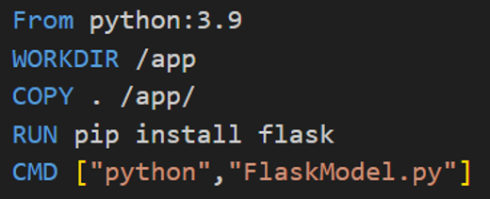

1. Image Building:

* Open docker desktop
* Open CMD in the folder, and run the following commands.
* Docker build –t image name.
* The built image image will be seen on docker desktop.

1. Docker Hub: Log in to your docker hub online. Click on Create Repository and fill in the credentials.
2. Image Pushing To Docker Hub:

* Run the following commands on the cmd to push the image to the docker hub.
* docker tag local-image:tagname new-repo:tagname
* docker push new-repo:tagname

1. Now our image is pushed to the docker hub

**KUBERNETES**

1. Kubernetes Installation:

* Run the following command in CMD
* curl.exe -LO https://dl.k8s.io/release/v1.29.2/bin/windows/amd64/kubectl.exe
* Check the version using the following command
* kubectl version –client

1. Docker Settings:

* Open docker Hub
* Click on settings
* Choose container terminal as integrated
* Tick on (Expose daemon on tcp://localhost:2375 without TLS)
* Click on apply & restart

1. Kubernetes Commands:

* kubectl config view
* Kubectl get nodes

1. Yaml File: Build a deployment.yaml in the same folder using the following code.

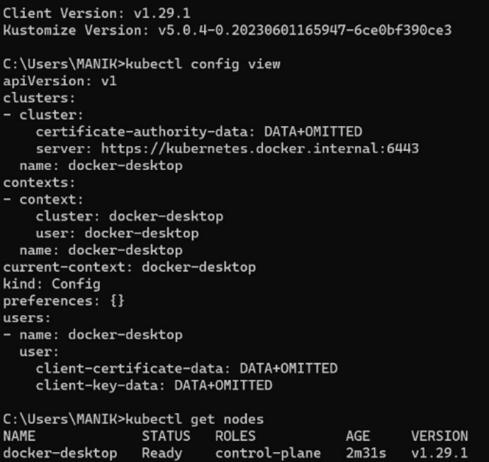

1. Deployments:

* Use the following command to deploy the model.
* kubectl apply -f deployments.yaml

**GITHUB**

1. Make new repository and upload the dockerfile and the machine learning model.

**JENKINS**

1. Log in to Jenkins using your local host.
2. Click on the new Item & enter the item name to create a new pipeline.
3. Click on pipeline.
4. Click on the “GitHub hook trigger for GITScm polling” and enable it.
5. Now write the pipeline script.
6. Enable Use Groovy Sandbox.
7. Now build the project.